JIRA EXPERIMENTS

Name : Spandana (192525160)

Create a Kanban Board using Jira or Trello with To Do, In Progress, and Done columns, add at least five tasks, and simulate the workflow by moving tasks across the columns.

Aim:
To create a Kanban Board in Jira and simulate task movement using the To Do, In Progress, and Done workflow.

Procedure:
  - Log in to Jira.
  - Create a Company-managed Kanban project.
  - Verify the workflow columns: To Do, In Progress, and Done.
  - Add five sample tasks to the board.
  - Move the tasks between the columns to simulate the project workflow.
  - Verify the final distribution of tasks across the workflow columns.

Output:
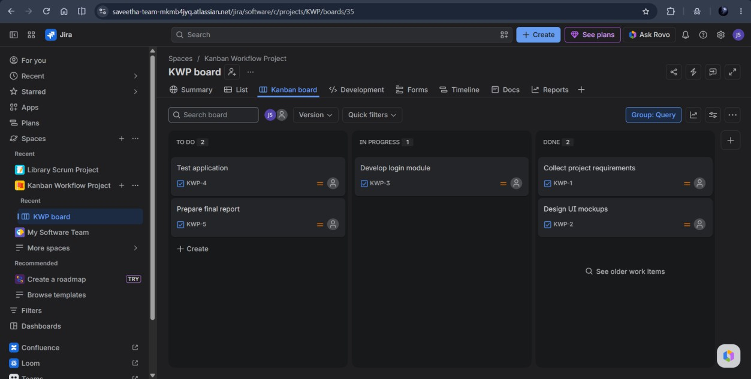

Result:
A Kanban board was successfully created in Jira (Company-managed project), and the tasks were moved across the workflow stages to demonstrate project progress.

Create a Kanban board using Jira or Trello with To Do, In Progress, and Done columns, add at least five sample tasks, and simulate the workflow by moving the tasks across the columns.

Aim:
To create a Scrum project in Jira, add and prioritize backlog items, create a one-week sprint, start the sprint, and track task progress using the sprint board.

Procedure:
  - Log in to Jira and create a Company-managed Scrum project.
  - Add five backlog items (stories) to the project.
  - Prioritize the backlog items based on their importance.
  - Create a 1-week sprint and move all backlog items into the sprint.
  - Start the sprint and view the Active Sprint board.
  - Simulate task progress by moving issues to the To Do, In Progress, and Done columns.
  - Complete the sprint.

Output:
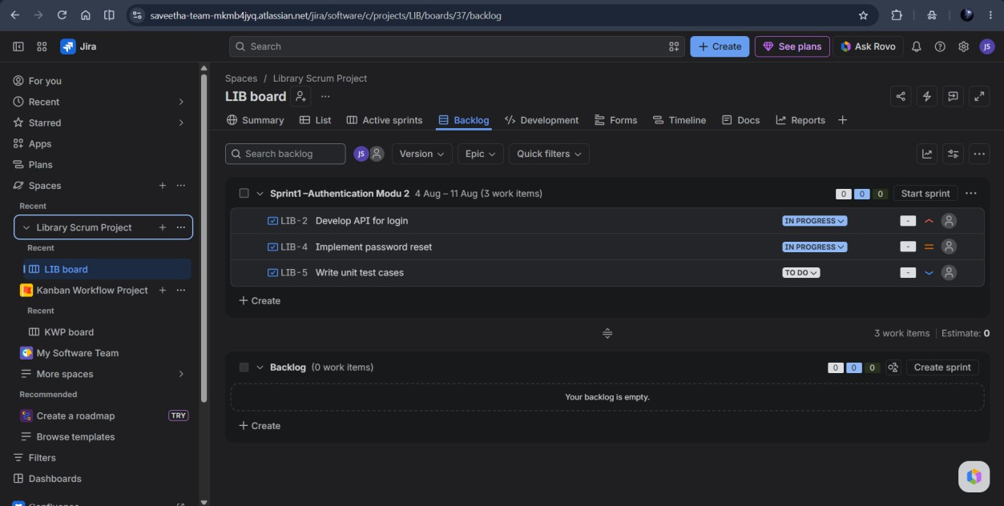

Result:
Thus, a Kanban board was successfully created and the tasks were moved across the columns to simulate the workflow.

Link Jira tasks with Confluence to streamline task tracking and progress monitoring for the Library Management System by embedding Jira issues and displaying a progress bar.

Aim:
To link Jira issues with Confluence pages to streamline task tracking, monitor progress, and visualize sprint completion for the Library Management System development.

Procedure:
  - Create a Confluence page titled Library Management System Project Overview.
  - Add a brief project introduction.
  - Embed Jira work items from the Library Scrum Project using the Jira Work Items macro.
  - Display the issue details and status of each work item.
  - Add a sprint progress section showing task completion.
  - Publish the Confluence page.

Output:
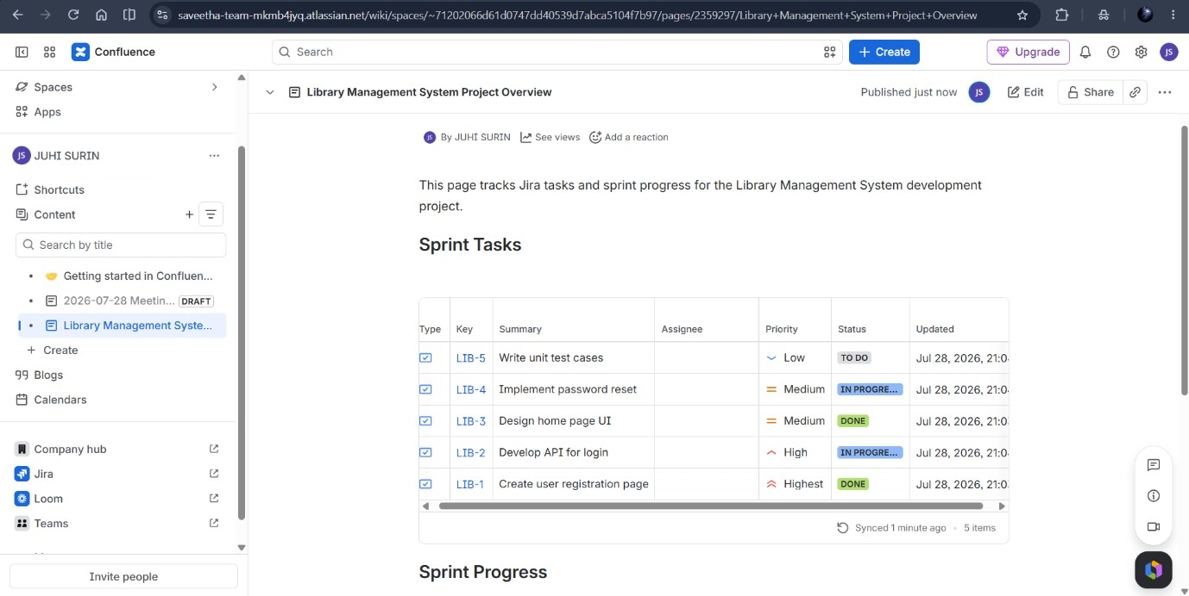

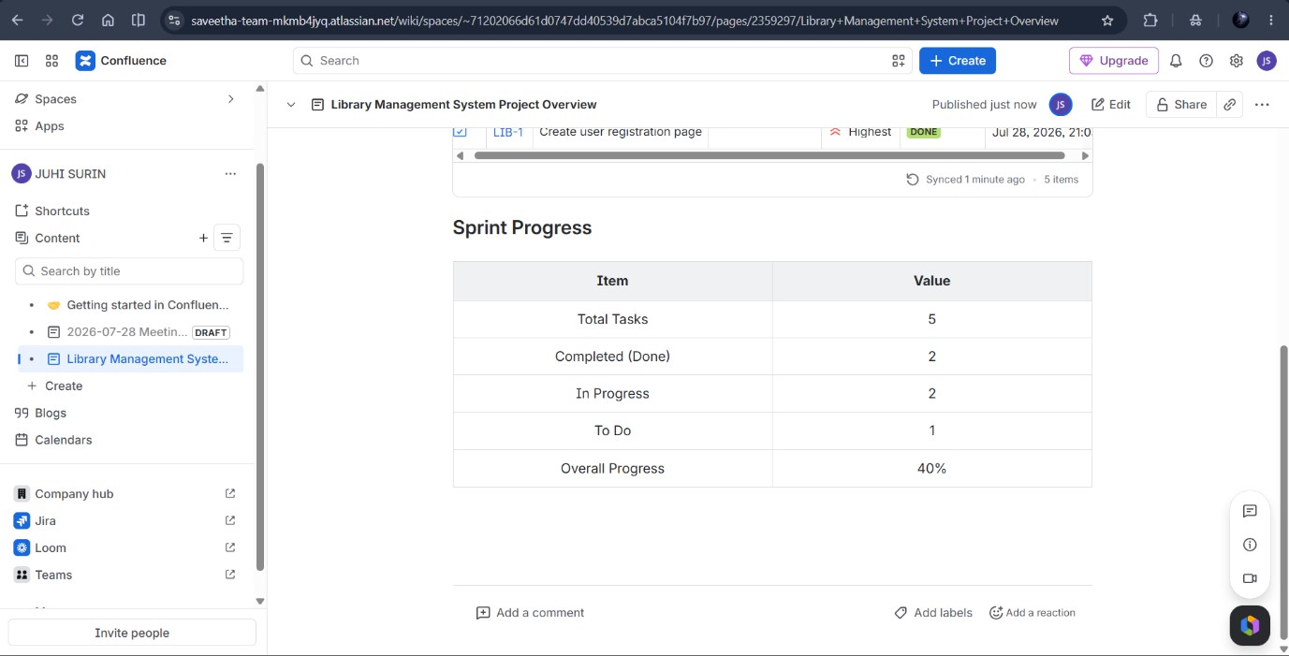

Result:
Thus, Jira tasks were successfully linked with Confluence to track the development progress of the Library Management System using embedded Jira issues and a progress bar.

Requirement Prioritization of a Task Management System Using MoSCoW and Kano Models in Jira.

Aim: To prioritize Task Management System requirements using MoSCoW and Kano models in Jira.

Procedure:
  - Open Jira and create a new project named Task Management System.
  - Create issues for the required features such as User Login, Task Creation, Task Prioritization, and Progress Tracking.
  - Prioritize all the requirements using the MoSCoW technique by assigning them as Must-Have, Should-Have, Could-Have, or Won't-Have.
  - Classify each requirement using the Kano Model as Basic, Performance, or Excitement feature.
  - Update the Jira issues with the selected priorities and organize them on the Kanban Board according to their status.
  - Verify the prioritized requirements and submit the final Jira board as the experiment output.

Output:
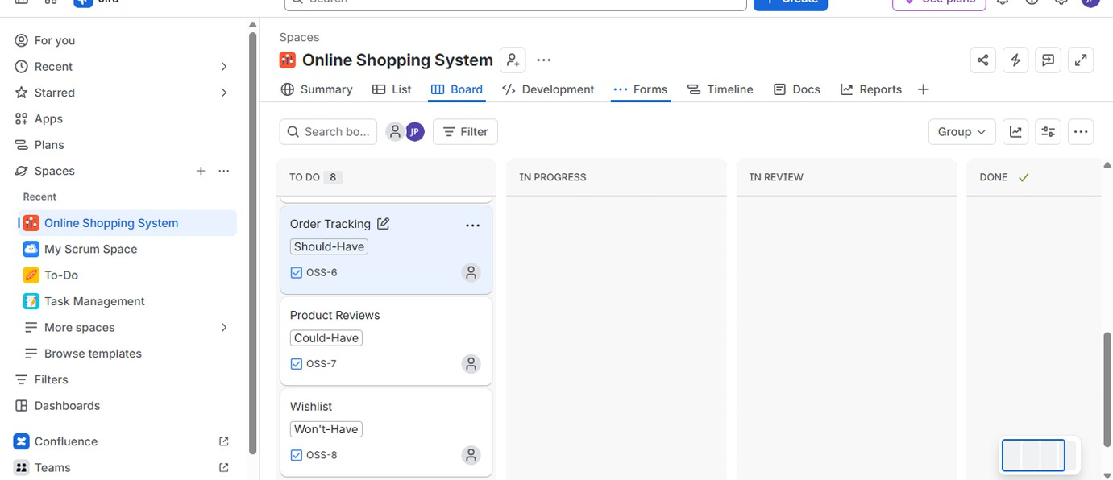

Result:
The Task Management System requirements were successfully prioritized using the MoSCoW and Kano models in Jira.

Categorize and prioritize the requirements of an Online Learning Platform using the MoSCoW and Kano models in Jira.

Aim:
To categorize and prioritize the requirements of an Online Learning Platform using the MoSCoW prioritization technique and the Kano model in Jira.

Procedure:
  - Open Jira and create a new project named Online Learning Platform.
  - Add issues for features such as Course Enrollment, Video Streaming, Quizzes, Progress Tracking, Discussion Forum, and Certificate Generation.
  - Prioritize all the requirements using the MoSCoW model as Must-Have, Should-Have, Could-Have, or Won't-Have.
  - Categorize each requirement using the Kano Model as Basic, Performance, or Excitement feature.
  - Update the Jira issues with the assigned priorities and organize them on the Kanban Board.
  - Review the prioritized requirements and save the final Jira board for submission.

Output:
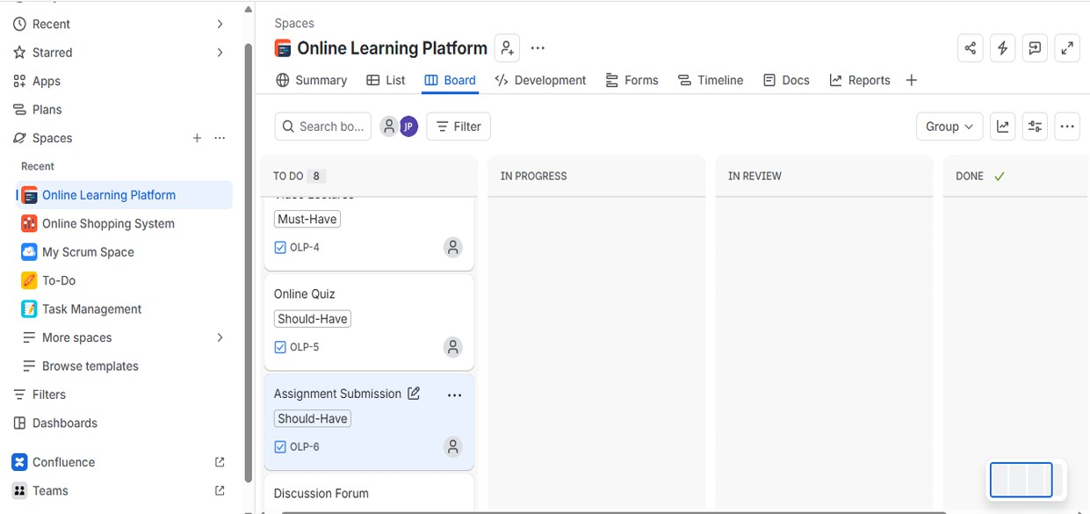

Result: The Online Learning Platform requirements were successfully prioritized using the MoSCoW and Kano models in Jira.

